**TEST PLAN:**

**Application XXX**

**Date**

**Prepared by:**

**Version 1**

**Draft**



**1. Document Information**

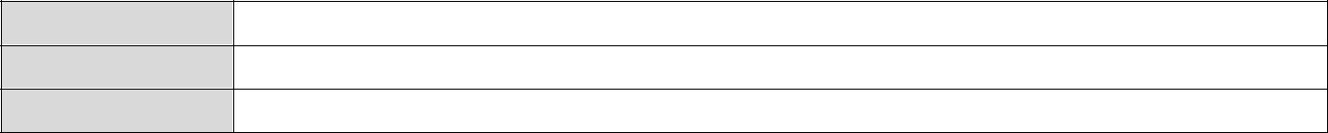

**Prepared By Anand Chauhan**

**Version** 1.1

**Status** Draft

**2. Revision History**

|  |  |  |  |
| --- | --- | --- | --- |
| **Date** | **Version** | **Description** | **Author** |
|  |  |  |  |
|  |  |  |  |
|  |  |  |  |
|  |  |  |  |
|  |  |  |  |



**3. Introduction:**

Test Project will involve the following:

1. Aaaaa
2. Bbbb
3. ccccc

This document describes the necessary information required to effectively define the approach which will be used while testing the product.

**4. Objective:**

The objective of this test plan is to define the various testing efforts, testing strategies and testing approach to be used in order to complete e2e testing.

**5. In-Scope:**

“All must have” requirements will be in our scope of testing. In addition, all other new requirements will be included. These are the key areas which the QA Team will test in this phase:

5

**6. Out-of-Scope:**

Some of the areas which are out of scope in our testing which are:

**7. Test Strategy:**

The project is using Agile approach with daily interactions. Requirements will be delivered on daily basis and will be tested accordingly.

1. **Testing Approach when sufficient time is given to QA:**

* Understanding the requirements
* Raising queries and getting responses on the queries
* Creating Test Cases
* Creating Test Data
* Executing Test Cases
* Defect Reporting
* Retesting Defects and Regression
* Production Deployment

1. **Bug Life Cycle:**

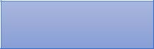

New Defect

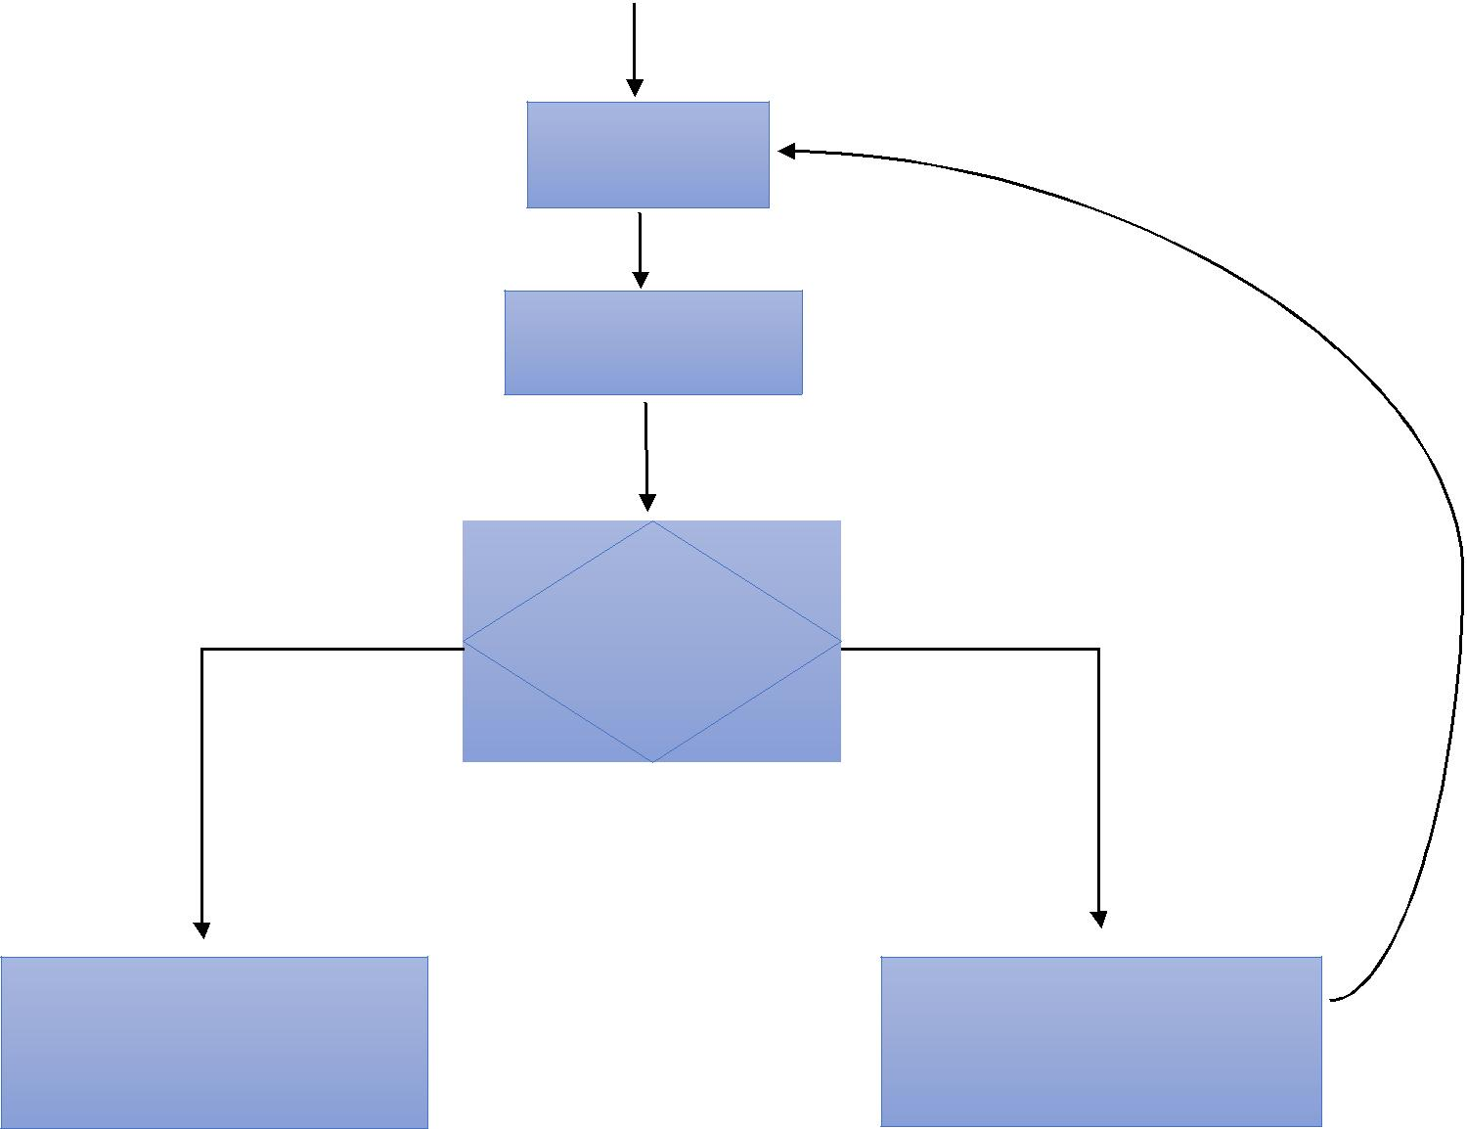

Assigned to the developer

Developer fixes the defect

Resolved

(Y/N)

If fixed, reporter marks it as fixed and closes the defect

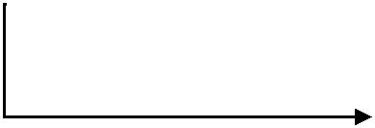

If not fixed, reporter reopens the defect and assigns it back to the developer

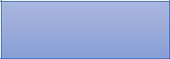

Closed

**8. Testing Types to be performed:**

1. **Black Box Testing/Functional Testing**

Testing all functional requirements of the software.

1. **GUI Testing:**

Testing UI of the application. It includes look and feel, warning messages, colors, and other cosmetic things (EOL)

1. **System and Integration Testing:**

Testing the integration between the applications to make sure that everything is integrated properly and data is flowing correctly between the applications.

1. **Compatibility Testing:**

Perform compatibility testing on the combination of different operating systems and browsers.

**9. Test Automation:**

No functional tests have been automated for this project right now.

**10. Test Environment:**

**Testing URL:**



**11. Test Schedule**

|  |  |  |
| --- | --- | --- |
| **Task Name** | **Start Date** | **End Date** |
| Test Planning |  |  |
| Test Case Creation |  |  |
| Functional Testing |  |  |
| Test Case Execution |  |  |
| System Testing |  |  |
| Regression Testing |  |  |
| Final Testing |  |  |
| Production Deployment |  |  |

**12. Risks and Assumptions**

**12.1. Risks:**

**12.2. Assumption**

1. **Entry Criteria**
2. **Exit Criteria**
3. **Tools to be used:**
4. **Deliverables:**

|  |  |
| --- | --- |
| **Deliverable** | **Responsible** |
|  |  |
| **Test Plan** | QA Team |
|  |  |
| **Test Cases** | QA Team |
|  |  |
| **Test Execution Report** | QA Team |
|  |  |



**17. Roles:**

|  |  |
| --- | --- |
| **Role** | **Name** |
|  |  |
|  |  |
|  |  |
|  |  |
|  |  |
|  |  |
|  |  |
|  |  |
|  |  |
|  |  |
|  |  |

